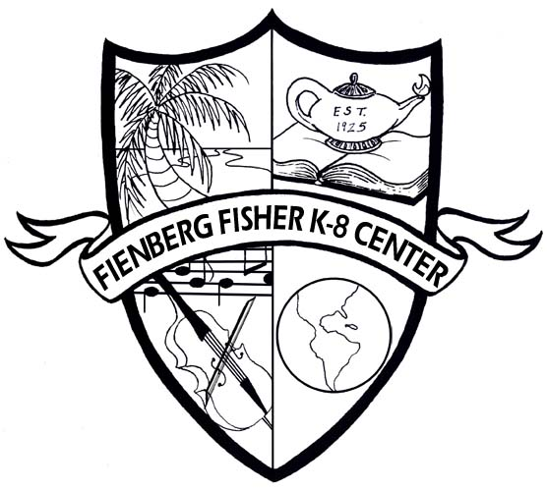

WELCOME TO FIRST GRADE

Supply List

Congratulations! Your child is in first grade! I am so pleased that your child is in my class this year. Your child will be learning many new and exciting things in our classroom. In order to complete our class work your child needs the following school supplies. Please label your child’s supplies with his or her name in permanent ink. These supplies will be used DAILY, the will remain at school with the exception of the book bag. Please replenish supplies as needed.

Book bag
Supply Box or Bag
1 pack of sharpened #2 pencils with erasers
2 large erasers
1 box of 24 crayons
1 glue stick
1 glue bottle
1 pair of child’s scissors
1 box of tissues
1 box of antibacterial wipes
1 IB Portfolio sold at the PTA Store
1 one-inch white binder with a clear plastic front pocket
1 sharpener with a cover
4 black/white composition notebooks
3 blue folders
1 red folder

Please have these materials at home for completing homework:
Pencils with erasers
Crayons
Scissors
Glue stick

Thank you so much for your help and cooperation!!

First Grade Team

